Conversational AI

Organizations are turning to AI solutions to make use of AI agents, called bots, to provide first-line of automated support through a full range of channels used to communicate with users in a conversational manner.

Messages are typically exchanged in turn during conversations, and one of the most common types of conversational exchange is a query followed by an answer. This pattern serves as the foundation for numerous user support agents and is frequently derived from extant FAQ documentation. To implement this sort of solution, you will require:

* A knowledge base of question-and-answer pairs, typically with a natural language processing model that enables queries that can be formulated in multiple ways to be understood semantically.
* A bot service that interfaces with a knowledge base via one or more channels.

This can be done using a combination of 2 core services:

* **Azure AI Language** includes custom question answering feature enabling us to create a knowledge base of QnA pairs that can be queried using natural language input.
* **Azure Bot Service** provides a framework for developing, publishing, and managing bots on Azure.

NOTE: Knowledge base can be created, trained, published, and managed using Azure Language Studio’s custom question-answering feature.

# Types of Conversational AI

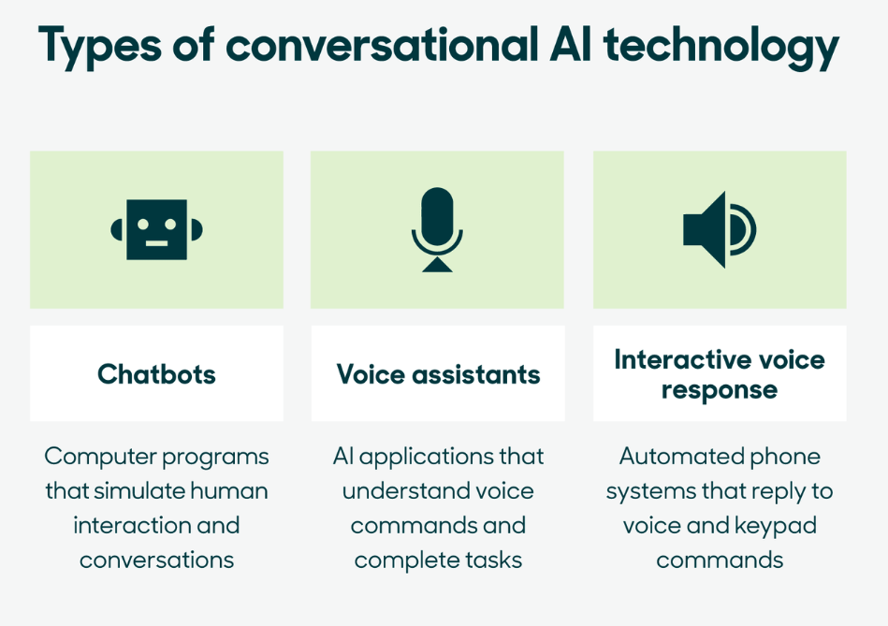

There are various conversational AIs that we use in our lives daily, without even noticing the complexity of these inventions.

1. Virtual Assistants (like Siri, Alexa, Bixby, Google assistant) are used with voice commands.
2. Customer support chatbots (like on various websites and apps).
3. Language translations by text and voice inputs.
4. Personalized recommendations on streaming services (like Netflix, YouTube, Spotify etc.).
5. Social media and messaging platforms use AI algorithms to suggest friends to connect with, filter out spam, and predict the content we would like to see.
6. News and content curation by AI algorithms based on a user’s interests, ensuring consumers receive relevant information.

Chatbots

An artificial intelligence chatbot is a piece of software that can have a conversation with a human user. AI chatbots are commonly used in numerous industries for a variety of purposes.

Chatbot is a software application or web interface aiming to mimic human conversations through texts or voice interactions. These are typically online and use AI systems capable of maintaining a conversation with a user in NL and simulate the way a human would behave as a conversational partner. Such technologies often utilize aspects of [deep learning](https://en.wikipedia.org/wiki/Deep_learning) and [natural language processing](https://en.wikipedia.org/wiki/Natural_language_processing), but more simplistic chatbots have been around for decades prior. It is designed to work without the assistance of a human operator, as far as possible. It communicates similarly to instant messaging.

There are 2 kinds of chatbots, standard and self-learning. Standard chatbots are the ones which relay only on the stored information, while self-learning chatbots learn from the information (or scenario) provided by the user.

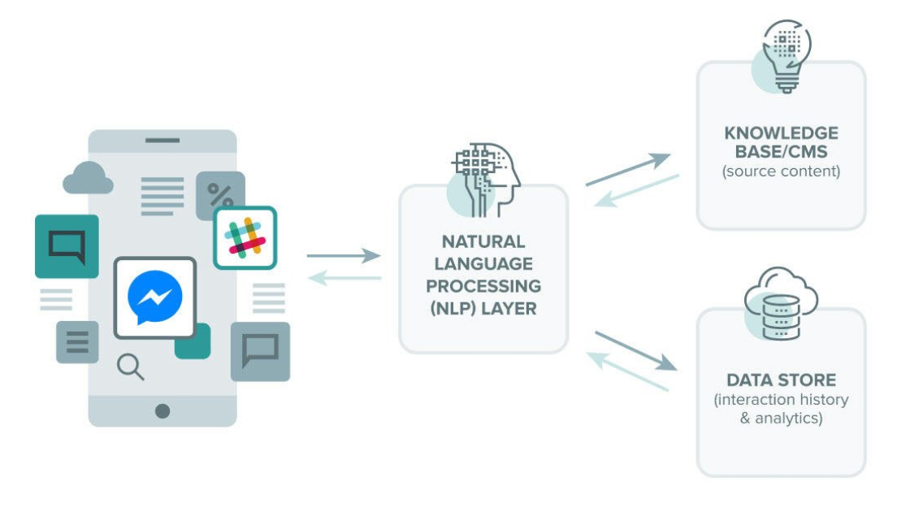

# Working

AI chatbots employ natural language processing (NLP) to assist users in interacting with web services or applications via text, images, or speech. Chatbots are able to comprehend natural human language, imitate human conversation, and carry out simple automated duties. Moreover, AI chatbots use predictive intelligence and analytics to learn a user's preferences in order to provide recommendations and anticipate requirements.

Various channels, including messaging apps, mobile apps, websites, phone lines, and voice-enabled apps, employ AI chatbots. They can be programmed to respond to a handful of simple commands or to function as complex digital assistants and interactive agents. A chatbot can be part of a larger application or entirely independent.

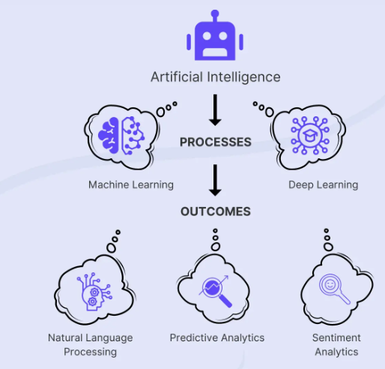

# Uses

Improvements in AI, machine learning, data science, and natural language processing have enabled the proliferation of chatbots by making it easier to [build conversational bots](https://powervirtualagents.microsoft.com/en-us/build-a-chatbot/) for a variety of applications that benefit companies, their customers, and their employees.

AI programs offer numerous benefits to businesses. Numerous businesses use AI chatbots as virtual agents for customer service and employee support. Companies that use chatbots for customer service have a high return on investment (ROI) as a result of enhanced customer service and lower customer service costs.

Using AI chatbots assists businesses in accelerating their sales cycles, generating more leads, and increasing customer loyalty. Companies use chatbots and AI to create personalized user experiences, resulting in happier, more engaged, and more profitable customers.

In addition to their high ROI, AI chatbots are gaining popularity because they provide a basic, convenient service that customers and employees have come to expect and rely on. As organizations invest in increasingly complex technologies and develop multiple communications interfaces, chatbots are swiftly becoming a necessary bridge between customers and employees, as well as the vast quantities of information, systems, and applications with which they interact.

AI chatbots in the workplace can also benefit the employees who work there. AI chatbots can be used to automate simple tasks, which frees up employee time. They can also be used within organizations to help employees navigate company policies, procedures, HR information, and other internal systems and documentation.

An AI Chatbot can be used in for various services by an enterprise. **Customer Service** can use it to create virtual customer service agents that are always available, which leads to more satisfied customers, as well as to file and acknowledge help desk requests or perform routine tasks for customers. **Human Resources** can be use it to help employees file for paid time off or sick leave, notify employees of policy changes, and help employees understand and manage their benefits. **Finance and Accounting** can use it to assist employees with filing expense reports, opening purchase order requests, and updating and keeping track of vendor details. Marketing can use it to send targeted offers to loyal customers, track customer satisfaction, and build personalized experiences that keep customers engaged, while **Sales** use it to pre-qualify leads, provide quotes to potential customers, and start a proactive conversation, which frees up time for salespeople to focus on closing sales.

# Forms

There are various types of chatbots in the industry used on basis of the features. For instance,

1. Informational chatbots [used to provide information and (or) answer FAQs]
2. Transactional chatbots [used to felicitate and complete transactions]
3. Dynamic and contextual chatbots [advanced AI-powered conversational agents]

These can be further classified based on the industry requirements.

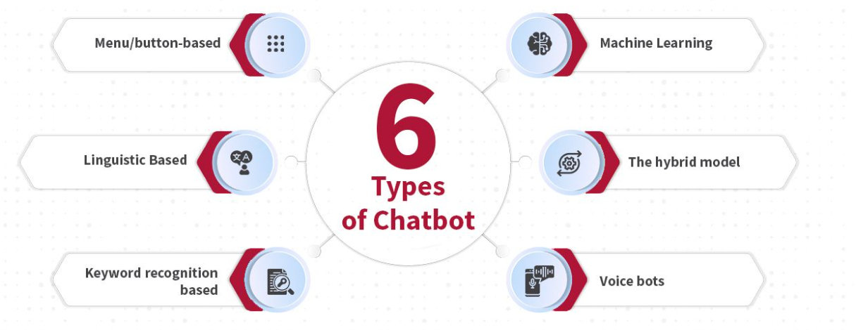

1. Menu / button-based chatbots [presents users with a structured menu of options to choose from]

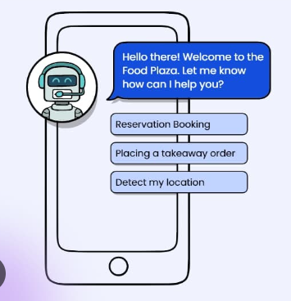

1. Linguistic based (Rule-based chatbots) [use ‘if’ or ‘then’ conditions to generate conversational streams]

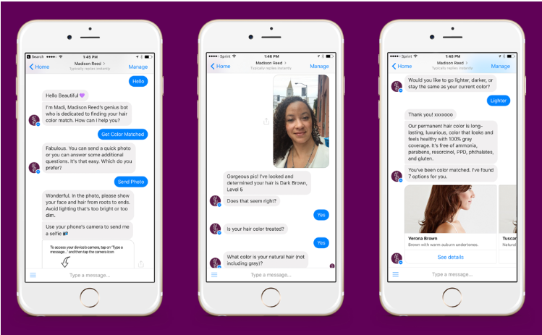

1. Keyword recognition-based chatbots [uses NLP to serve its users by selecting keywords from the prompt]

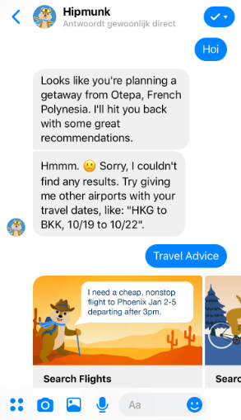

1. Machine Learning chatbots [enables users to ask open-ended and advanced questions offering natural responses]

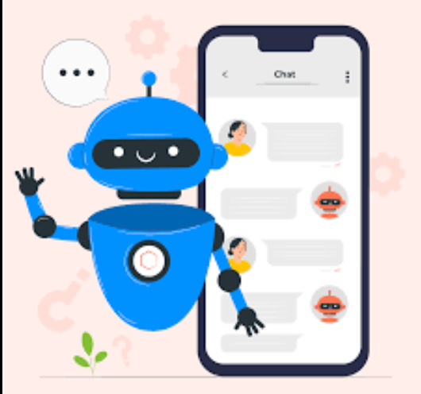

1. Voice bots [voice-activated bots bringing frictionless experience directly to the users {Alexa, Siri}]

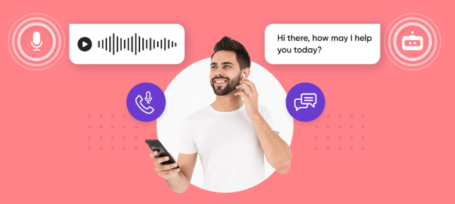

1. Hybrid chatbots [rule-based + AI]

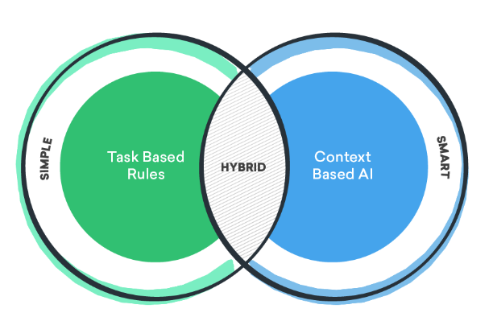

### **Innovative examples of Chatbots**

1. Endurance: companion for dementia patients.
2. Casper: helping insomniacs get through the night.
3. UNICEF: helping marginalized communities be heard.
4. MedWhat: Making medical diagnosis faster.
5. NBC: helping newshounds navigate the headlines.
6. Disney: solving crimes with fictional characters.
7. Marvel: guarding the galaxy with comic-book crossover.
8. Roof AI: generating and assigning leads automatically.

# Rise of chatbots

Last decade has seen chatbots through prolific rise from the failure of Facebook’s chatbot to phenomenal breakthrough with Facebook’s Alice and Bob Chatbots. Since chatbots have added greatly to the growth of businesses worldwide.

For example,

1. Emirates Vacation integrated a conversation bot within its display ads to boost engagement by 87% since its launch in 2018.
2. Madison Reed’s AR bot Madi that helped visitors desired hair colour based on a selfie they upload. This boosted engagement rates by 400% and CTR by 21%

When Covid hit, remote work and associated technologies helped minimize in-person interactions. Chatbots played a leading role in addressing queries at scale at a critical time which saved lives by the millions. The innovation born out of necessity during the pandemic accelerated the chatbot industry to progress quickly. The requirement for chatbots and their place in a world where automation is a necessity became a sure thing.

# History

Chatbots are all the buzz these days, but many do not know that humans have been trying to interact with computers via bots way before the time computers became a household phenomenon.

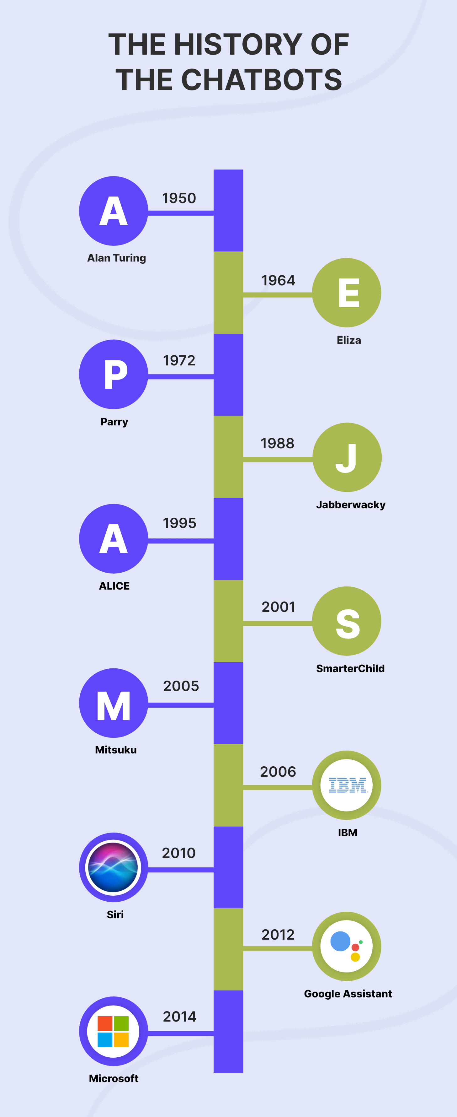

# Terminologies

1. Natural Language Understanding (NLU)

Algorithms sift through the complexities of the language and extract the required information.

1. Platform

Channel that hosts a conversation. It allows marketers to build and maintain chatbots for various messengers.

1. Webhooks

API responses that extract information from chatbot conversations and pass them on to web services. This information can be in the form of email addresses, names or telephone numbers of potential customers who have visited your website.

1. Entities

Knowledge banks used by a chatbot to provide a more personalized user experience. Entities can be text or fields describing an item, a place, numbers, or anything else that the chatbot can use to provide a more personalized user experience.

1. Attributes

Packets of information that include user data such as name, mobile number, and email that chatbots collect during the process of chatting with the user. They are used by chatbots to personalize their response to the user with which it is chatting.

1. Quick reply

Helps your chatbot to give users possible options for their queries, thereby making the user experience a lot better.

1. Hybrid chat

Combination of [live chat](https://www.kommunicate.io/product/live-chat?utm_source=ucg&utm_medium=interlink&utm_id=seo) and chatbot. The chatbot acts as the primary source of communication for the website visitor, and if the conversation is not resolved, it will hand over the conversation to a live human agent seamlessly. It is thus the best of both worlds.

1. Compulsory input

The information that a user must offer for the chatbot to function properly is compulsory input. If the user does not provide the required input, then the conversation with the bot will stall, halting the customer support process. For instance, an app that schedules appointments with medical professionals will require an appointment ID to proceed with the user query. Without the required input, the bot will not be able to fetch the availability of the doctor and other details.

1. Optional input

When users can have a meaningful conversation with the chatbot and get their query resolved without providing a specific input, that information is called optional input. For example, if a user is searching for a particular piece of apparel from an online store, then the user need not mention the brand name or the price range. Just the mention of the type of apparel is sufficient.

1. Intent

The motive behind a chat. It is what the user wants to convey to the website via the chatbot and is usually in the form of a text message, but can also be in the form of voice or other input methods.

1. Intent classification is organizing every user input into a preset intent group helps match varied inputs with their intent and provide a precise response. It helps the chatbot have more meaningful conversations and resolve queries better and faster.
2. Intent recognition lets chatbots identify user need or requirement. The chatbot tries to make sense of the input information based on user intent to provide efficient query resolution.
3. Decision tree

A decision tree is a diagram that displays in detail how decisions are made through set pathways based on previous decisions or inputs. In chatbots, decision trees are useful in the form of a flowchart, showing how a conversation will flow according to the inputs of the user and the responses programmed into the Chatbot. This way, you can ensure that the conversation with the user will effectively resolve their query.

1. Sentiment analysis

An offshoot of computer science using Machine Learning and NLP, that assesses the tone of a conversation or sentiment through various media such as text or the spoken word. Sentiment analysis can aid a chatbot in evaluating user messages to recognize how the user perceives the product as positive, negative, or neutral. Google’s advanced chatbot LaMDA is trained to use sentiment analysis and is more responsive to context and user tone.

# Future of chatbots

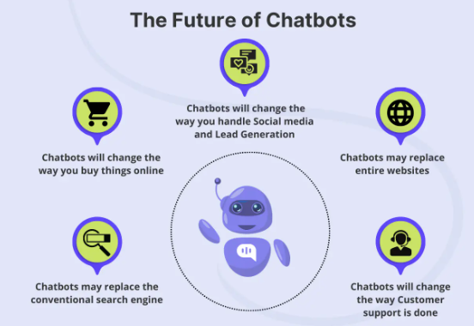

1. The Global chatbot industry is expected to grow from $2.9 billion in 2020 to $10.9 billion by 2026- Businesswire.
2. Chatbots are expected to handle 70%- 90% of healthcare and banking queries by 2022- CNBC
3. There are over 300,000 active chatbots on Facebook
4. ECommerce Transactions via Chatbots is projected to reach $112 billion by 2023.
5. Chatbots will save businesses 2.5 billion hours by 2023.

# SUMMARY

The custom question answering feature in Azure AI Language allows users to create and share a knowledge base consisting of questions and corresponding answers. This feature also supports the ability to query the knowledge base using natural language. When the Azure AI Bot Service is integrated with a knowledge base, it enables the creation of a bot that can provide intelligent responses to user inquiries across various communication channels.

The utilization of conversational AI solutions offered by these services has the potential to alleviate the support burden on human personnel. This, in turn, allows organizations to extend their user support capabilities on a global level.

# REFERENCES

* <https://icapps.com/blog/linguistics-behind-chatbots>
* <https://www.quora.com/What-is-the-difference-between-dynamic-response-chatbot-or-a-normal-chatbot>
* <https://chatimize.com/chatbot-types/#Keyword_recognition-based_chatbots>
* <https://3cloudsolutions.com/resources/information-chatbots-a-great-way-to-get-started-with-artificial-intelligence/>
* <https://www.wordstream.com/blog/ws/chatbots>
* <https://www.youtube.com/watch?v=X_aS-37IOq0&t=2755s>
* <https://www.ibm.com/topics/chatbots>
* <https://en.wikipedia.org/wiki/Chatbot>
* <https://www.engati.com/blog/types-of-chatbots-and-their-applications>
* <https://www.youtube.com/watch?v=bSvTVREwSNw&pp=ygUHY2hhdGJvdA%3D%3D>
* <https://www.youtube.com/watch?v=X_aS-37IOq0&t=43s>
* <https://www.youtube.com/watch?v=ERU8Ehq9fss&t=594s>
* <https://www.youtube.com/watch?v=Nh3S_sljkpI&t=132s&pp=ygUNYXp1cmUgY2hhdGJvdA%3D%3D>
* <https://www.kommunicate.io/ultimate-chatbot-guide#chatbot-terminologies>